Project 5: Written Report

Bernie Jones

CS 215

22 October, 2023

**Part 1:**

**GitHub Username:** bern1e

**Part 2:** A detailed **account of your process** that includes:

As an Economics major, a lot of my coursework has surrounded investigating different economic conditions and factors across the globe. On a previous project, I attempted to look at aggregate data of countries’ GDP per capita, but unfortunately it didn’t align within the scope of the project. With this framework in mind, for Project 5, I returned to GDP per Capita and its subsequent visualization across different countries. Off of *Our World in Data*, I utilized data from 1950-2019 to look at [Global GDP per capita](https://ourworldindata.org/grapher/gdp-per-capita-penn-world-table?tab=chart).

The Visualization of this data looked like so:

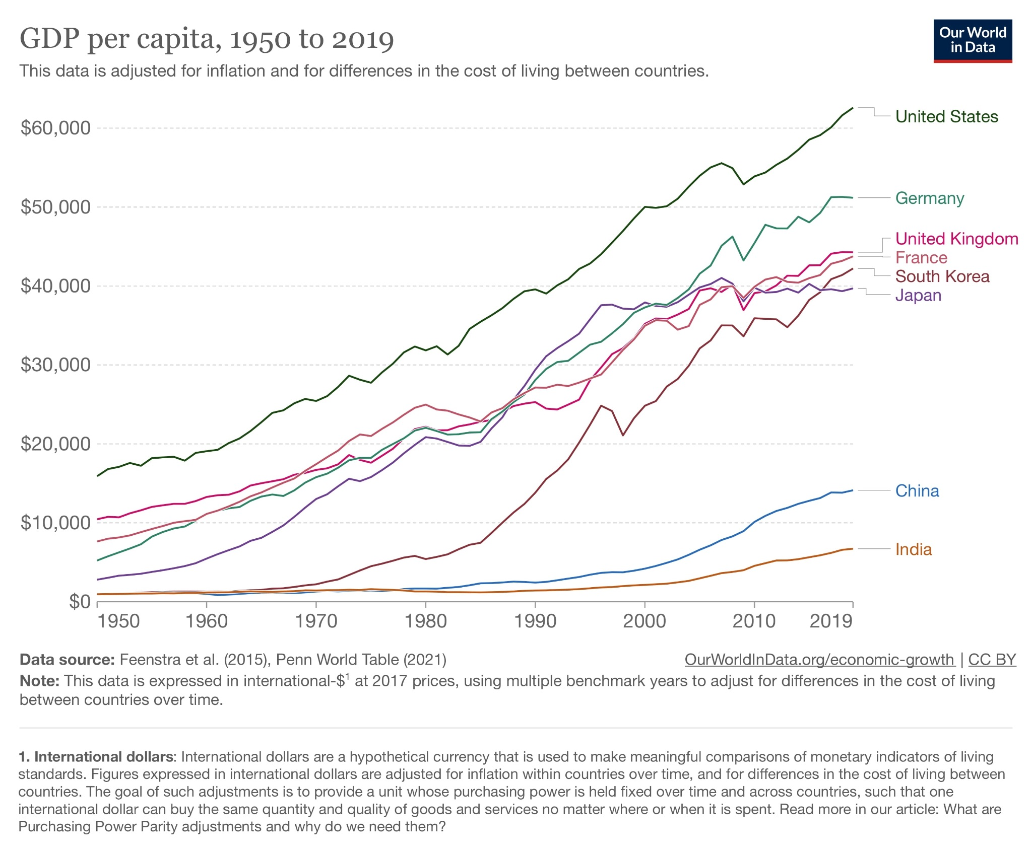

I recreated this visualization in three different formats: Jupyter Notebook (Python), via Excel, and lastly in RawGraphs.io

Python (Utilizing Pandas and Seaborn):

Pandas:

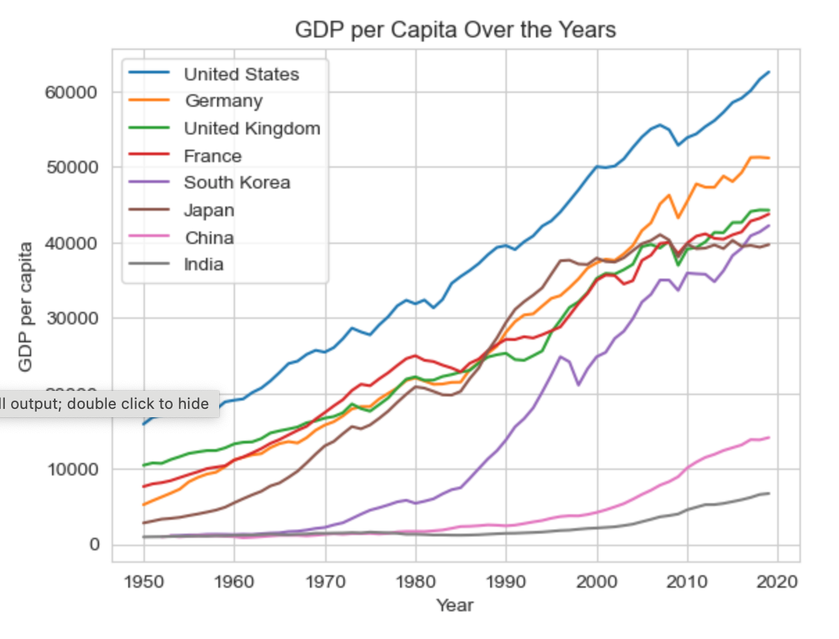

Seaborn:

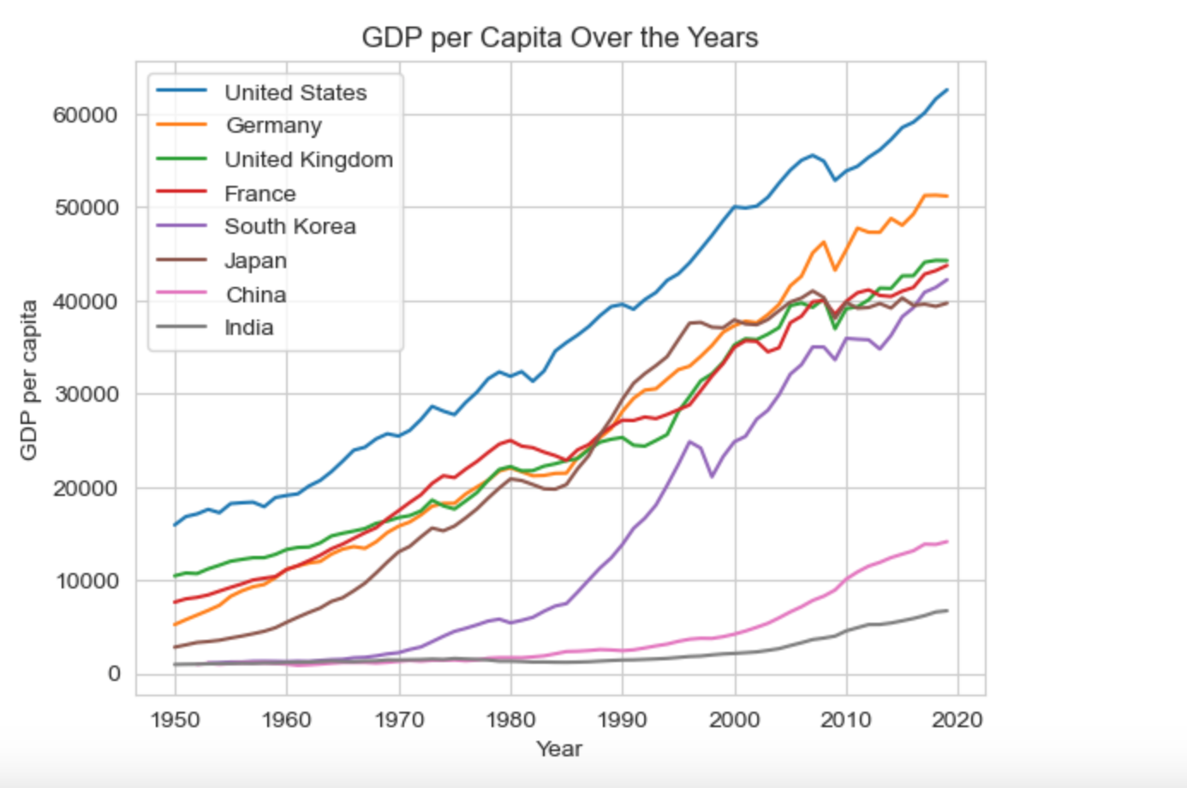

Excel:

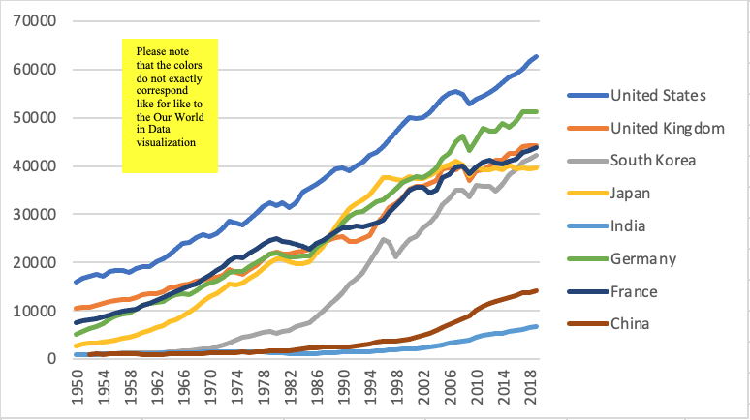

RawGraphs:

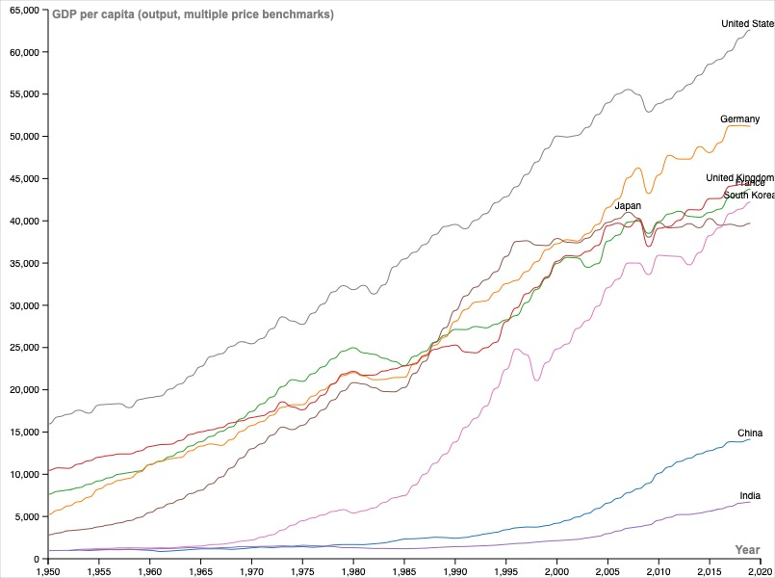

Reflection:

Each tool offered a unique experience to visualization. Leveraging Python for visualization provides a holistic experience that allows the creator to create multiple data-frames, visualizations and beyond. Speed of use or user experience wise however, other tools were slightly quicker to utilize, as they were more of the “drag and drop” accessibility. As someone with experience with Excel and the creation of Pivot Tables and Pivot Charts, excel was a familiar tool and one that similar to Python is and was highly leverageable. I’ve also heard of the leveraging of Python within Excel. I am not certain if this is a feature currently implemented or to come soon, but the utilization of both in one tool could and would be immensely powerful. Lastly, after initially attempting to create a visualization using Tableau (due to the time it was taking to extract, I switched over to another tool), I leveraged RawGraphs.io, which offered a very quick and simple experience. RawGraphs however did seem to have a limitation in not being able to filter for select criteria for the visualization. This led to me making an alternative CSV file, and passing this into the tool for the visualization. I think for its simplicity, it offers a great user experience and also is efficient in conveying things. I prefer Excel as a holistic tool for communication as switching from visualization to dataframe is easily done and available.

**Part 3:**

I have requested and received confirmation of requests for data from Youtube, Apple, and Amazon. I have requested data from two separate accounts from Youtube as one account is the account I’ve had for years, with the other being used infrequently. From Apple, there is a plethora of data being requested from maps, to music, to my wallet. Similarly my Amazon data request represents a plethora of information as well. Although I do not have access to the account as of now, I plan on requesting my data from Microsoft as this represents a gateway to many different companies as well (i.e Epic Games, EA Sports etc). I look forward to hopefully receiving all of this data in the near future.